Ever Health Fitness

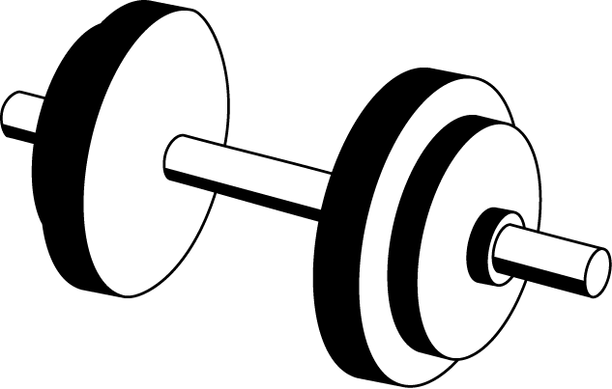

**About Us**

Ever Health Fitness is a chain of fitness centers operating in the state of Ohio. These Centers operate 24/7 for personal fitness. In 1973 two retired coaches, Hennery Truman and Michael Hatch opened the first center in Dayton Ohio. Several other locations were added with ten years and the chain expanded to suburban communities in other metropolitan areas across several cities in Ohio. Today Ever healthy fitness consists of more than twenty-four gyms with an estimated 1 million members across the State. Ever Health facilities include locker rooms, pools, children club where kids play with the supervision of their parents. For the last five years Ever Health introduced new advance equipment such as free weights, weight machines, stability devices, and cardiovascular equipment and fitness classes. Ever Health not only includes equipment and technology but also an atmosphere, view, innovation, tradition and uniqueness. Members of Ever-health are growing every day and many other centers are planned to be opened in the coming years.

**Mission Statement**

Our goal is to provide an environment that promotes accessibility to fitness equipment and knowledge to anyone that needs it. We aim to provide the tools necessary to start and maintain a healthy lifestyle.